I will be presenting pieces from my newest collections–Pizza My Heart and Count the Stars–with a sneak preview of something I’m working on now.

I will bring all of my books along to sell. Regular pricing is $20 per book, but I will also offer special convention pricing of 3 books for $50. (Single copies are at regular price).

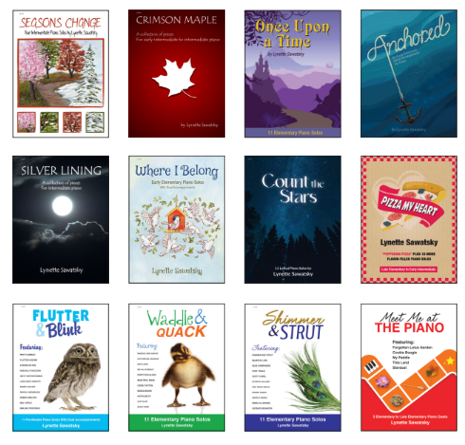

To check out levels of pieces in each book, please visit my website by following this link:
https://www.lynettesawatsky.com/index.php/shop/collections-of-piano-pieces
Click on any book to see a list of pieces and their grade level.

